1. **Total Revenue:** select sum(total_price) as Total_Revenue from pizza_sales



1. **Average Order Revenue:** SELECT sum(total_price)/count(distinct(order_id)) as Average_Order_Value from pizza_sales;



1. **Total Pizza sold:** SELECT sum(quantity) as Total_Pizza_Sold FROM pizza_sales

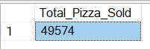

1. **Total Orders placed:** SELECT count(distinct(order_id)) as Total_Orders_Placed from pizza_sales



1. **Average Pizza Per Order:** SELECT cast(cast(sum(quantity) as decimal (10,2))/cast(count(distinct(order_id)) as decimal(10,2)) as decimal(10,2)) as Avg_Pizza_per_Order from pizza_sales;



1. **Daily Trends:** SELECT DATENAME(DW, order_date) as order_day, count(distinct(order_id)) as total_orders from pizza_sales group by DATENAME(DW, order_date)

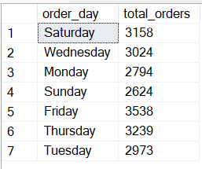

1. **Monthly Trends:** SELECT DATENAME(Month,order_date) as order_month, count(distinct(order_id)) as total_orders from pizza_sales group by DATENAME(Month,order_date) Order by total_orders desc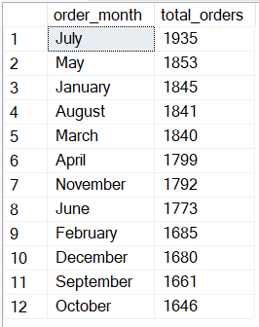
2. **Hourly Trends:** SELECT DATEPART(Hour,order_time) as order_hour, count(distinct(order_id)) as total_orders from pizza_sales group by DATEPART(Hour,order_time) Order by order_hour asc;

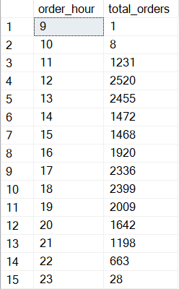

1. **Percentage of sales by pizza category:** SELECT pizza_category as Pizza_Category,cast(sum(total_price) as decimal(10,2)) as Total_Sales, cast(cast((sum(total_price))*100 as decimal(10,2))/ (select sum(total_price) from pizza_sales where MONTH(order_date)=1) as decimal (10,2)) as Perc_sales_by_pizza_category from pizza_sales WHERE MONTH(order_date) = group by pizza_category order by Perc_Sales_by_Pizza_Category desc;

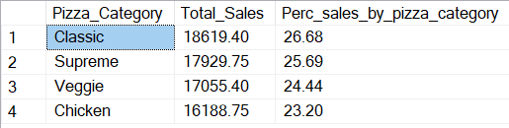

1. **Percentage of sales by Pizza Size:** SELECT pizza_size, cast(sum(total_price) as decimal (10,2)) as Total_sales, cast(sum(total_price)*100/(select cast(sum(total_price) as decimal(10,2)) from pizza_sales) as decimal(10,2)) as Perc_sales_by_pizza_size from pizza_sales group by pizza_size

order by Perc_sales_by_pizza_size DESC;

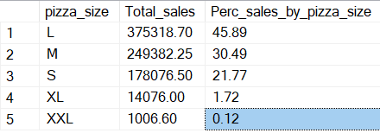

1. **Top 5 Pizza Name by Revenue:** SELECT TOP 5 pizza_name as Pizza_name, cast(sum(total_price) as decimal(10,2)) as Total_sales from pizza_sales Group by pizza_name Order by Total_sales DESC;

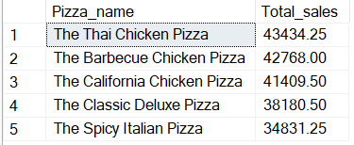

1. **Bottom 5 Pizza Name by Revenue:** SELECT TOP 5 pizza_name as Pizza_name, cast(sum(total_price) as decimal (10,2)) as Total_sales from pizza_sales Group by pizza_name Order by Total_sales;

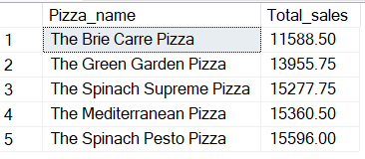

1. **Top 5 Pizza Name by Quantity:** SELECT TOP 5 pizza_name as Pizza_name, sum(quantity) as Total_Quantity from pizza_sales Group by pizza_name

Order by Total_Quantity DESC;

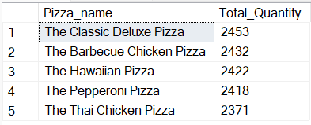

1. **Bottom 5 Pizza Name by Quantity:** SELECT TOP 5 pizza_name as Pizza_name, sum(quantity) as Total_Quantity from pizza_sales Group by pizza_name

Order by Total_Quantity ASC;

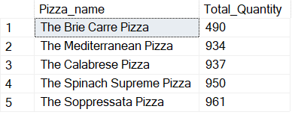

1. **Top 5 Pizza Name by Orders:** SELECT TOP 5 pizza_name as Pizza_name, count(distinct(order_id)) as Total_orders from pizza_sales Group by pizza_name Order by Total_orders DESC;

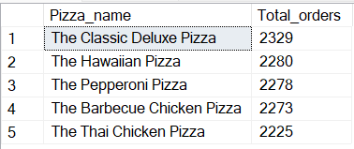

1. **Bottom 5 Pizza Name by Orders:** SELECT TOP 5 pizza_name as Pizza_name, count(distinct(order_id)) as Total_orders from pizza_sales Group by pizza_name Order by Total_orders ASC;

